### **Step 3: Write Basic Bash Scripts**

1. Brace expansion command to create the four subdirectories:

Solution:

~$ mkdir -p backups/{freemem,diskuse,openlist,freedisk}

Paste your system.sh script edits below:  
  
 #!/bin/bash

1. [Your solution script contents here]

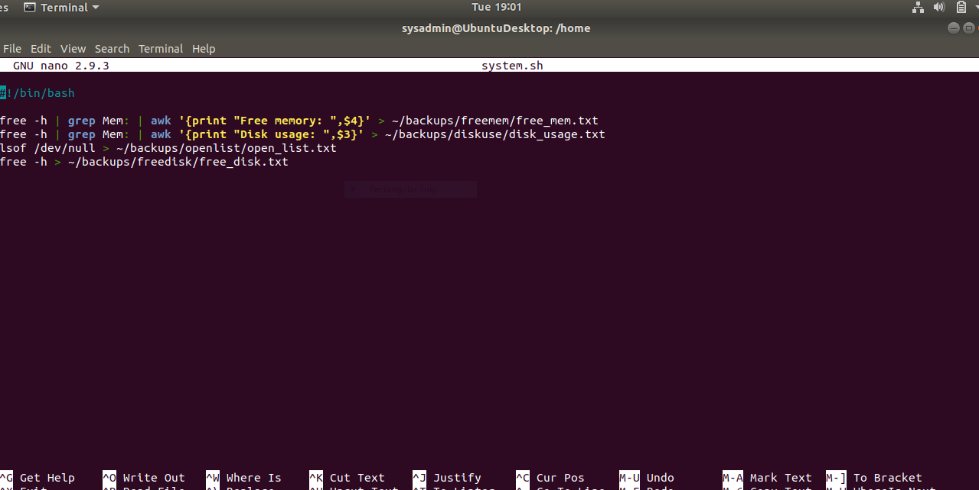

1. Command to make the system.sh script executable:

Solution:

/home$ sudo chmod +x system.sh

**Optional**

* Commands to test the script and confirm its execution:

Solution:

/home$ sudo ./system.sh

# Testing the execution result gives:

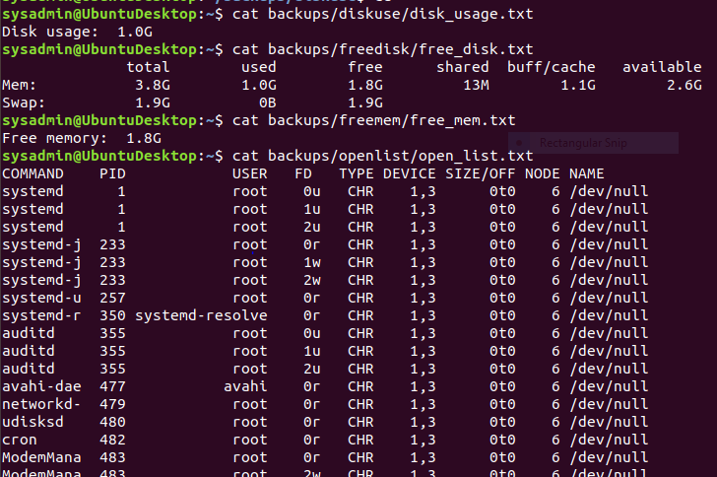

**Bonus**

* Command to copy system to system-wide cron directory:

Solution:

/home$ sudo cp system.sh /etc/cron.weekly/